Case 12-US-SD-Pine Ridge Indian Agency-Oglala-Deerskin Bag
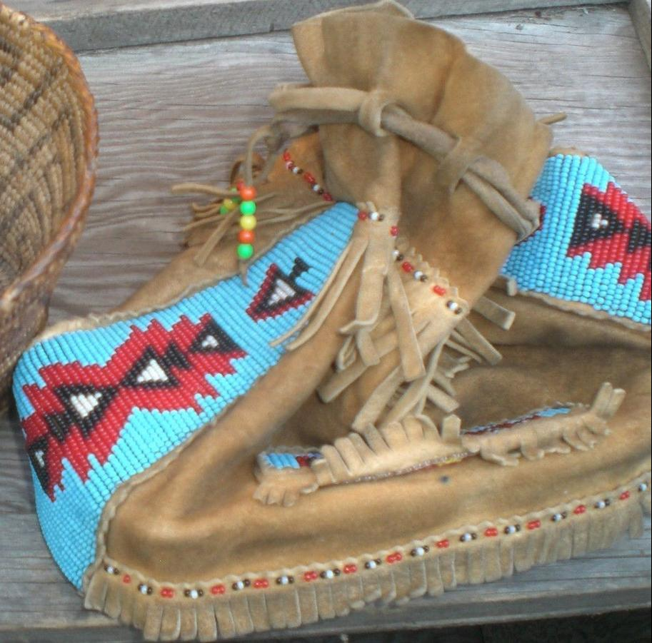
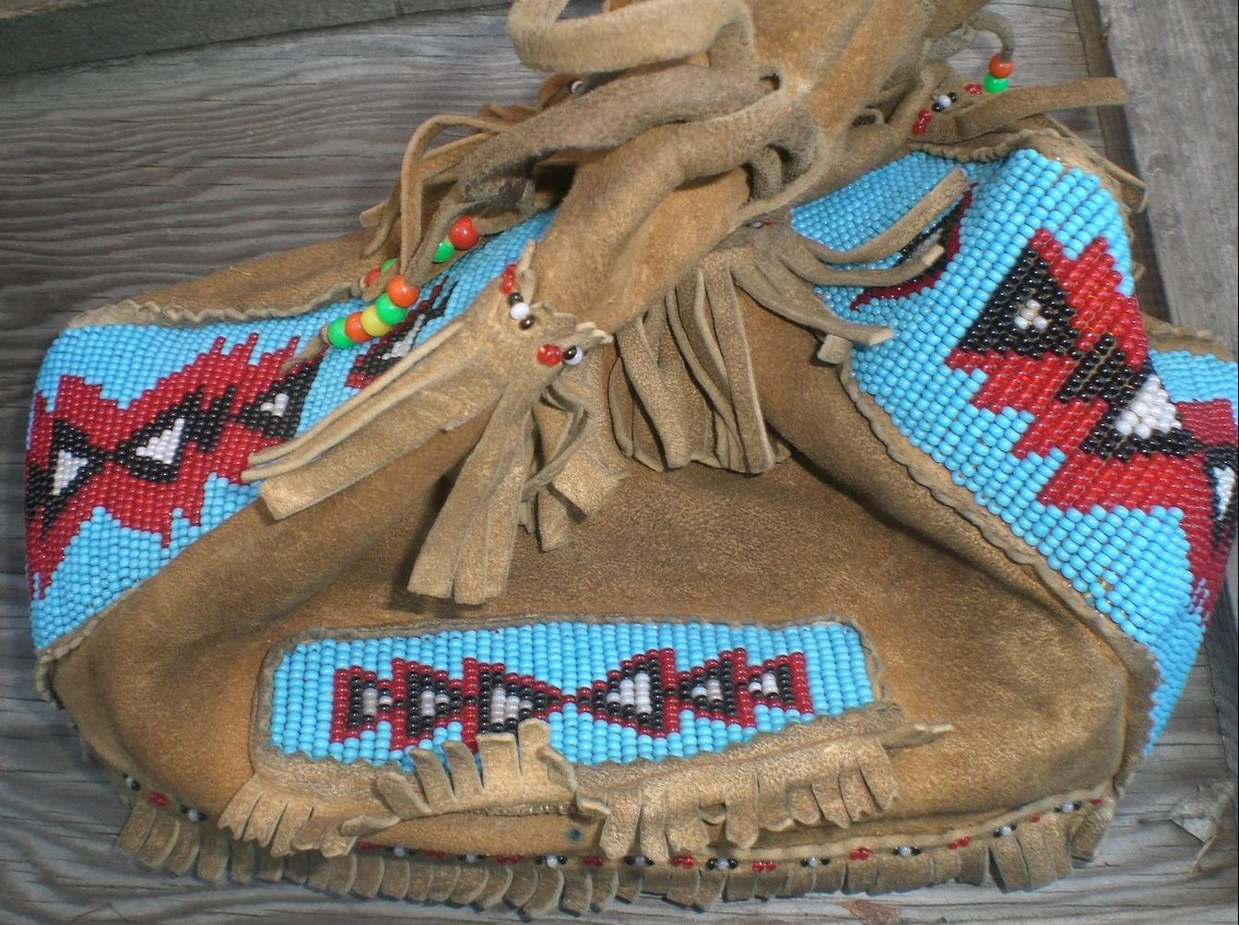

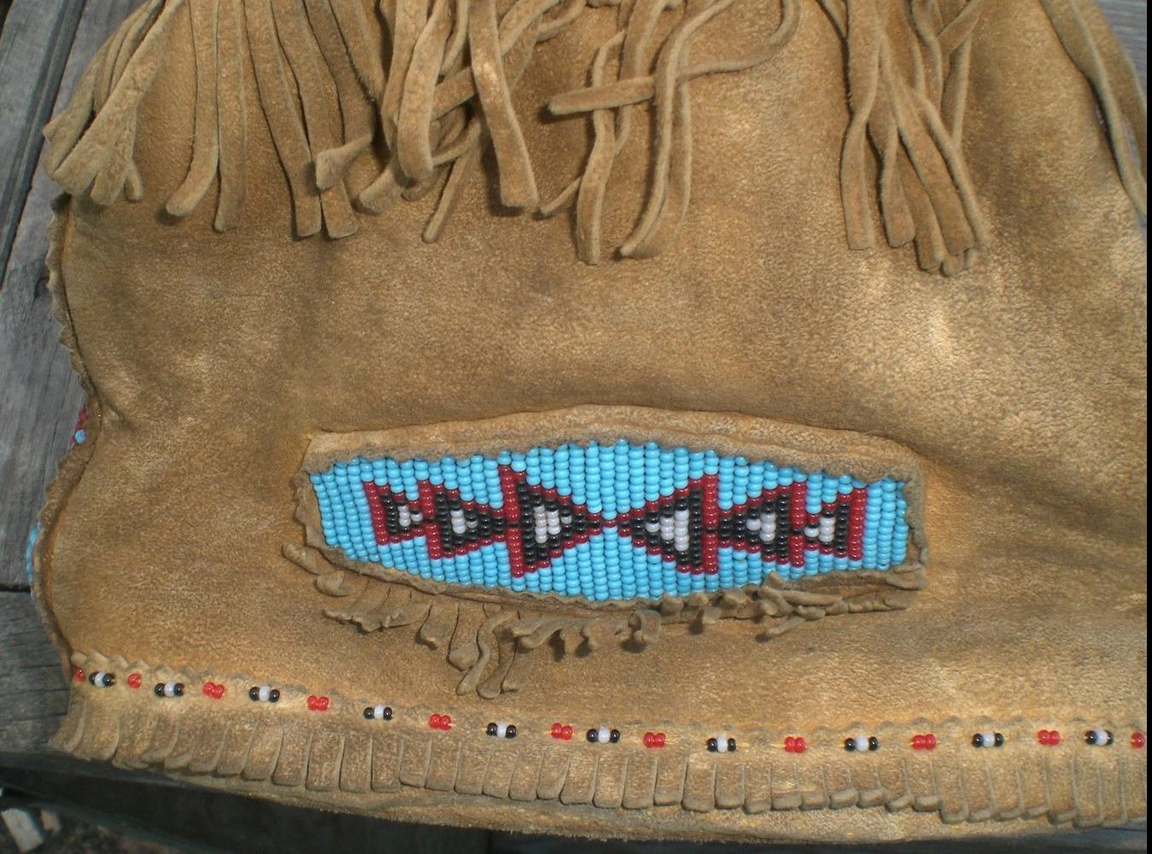
Case No.: 12
Accession Number:
Formal Label: US-SD-Pine Ridge Indian Agency-Oglala Sioux-Deerskin Bag
Display Description:
Brain Tanned deer skin tobacco bag with trade bead decorations
LC Classification:
Date or Time Horizon: 1920
Geographical Area: SW SD
Map: 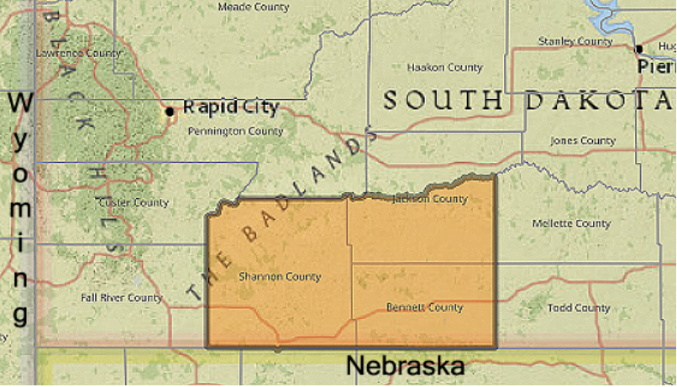
The official boundaries of the Pine Ridge Reservation in South Dakota.
GPS Coordinates:
Cultural Affiliation:
Medium: Deerskin, trade beads
Dimensions: Weight:
Provenance: Purchased from the Pine Ridge Indian Agency, 2011.
Condition:
Discussion:
References:

